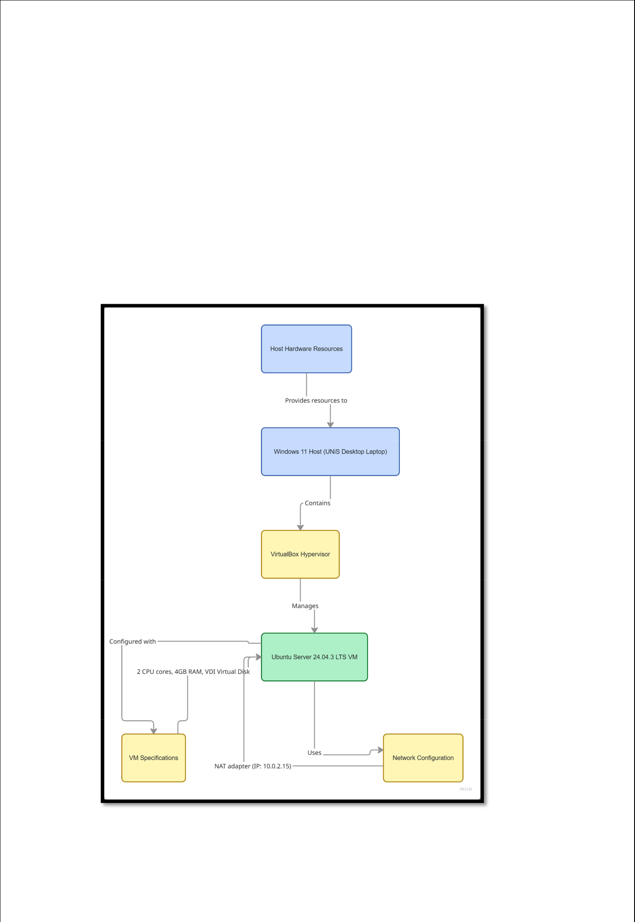
Operating System

Week 1

This week focused on installing a Linux server, configuring the virtual environment, collecting system information, and documenting the network configuration.
I installed Ubuntu Server 24.04.3 LTS (Noble Numbat) inside VirtualBox running on my Windows 11 workstation.

1. System Architecture Diagram:

Fabian Gill A00017906



2. Justification Comparison:

Here's your distribution comparison in text form:

Ubuntu Server brings a very beginner-friendly experience with excellent documentation, strong security updates through LTS releases, and huge community support. The main downside is that it's slightly heavier than Debian. I chose this distribution because it offers the best balance of ease, support, and documentation for my needs.

Debian is extremely stable, lightweight, and highly reliable. However, it comes with older software packages and documentation that's less beginner focused. I didn't choose it because the older package versions would slow down my learning process.

Rocky Linux provides enterprise-grade stability as a RHEL-compatible distribution, strong security with SELinux, and is ideal for production servers. The drawbacks are that it's more complex for beginners and uses heavier resources. I ruled this out because it's too advanced for a student environment.

CentOS Stream uses a rolling-release model that provides newer packages and is good for testing new features. On the flip side, it has less predictable stability and a smaller community than Ubuntu. I didn't choose it because rolling updates aren't ideal for coursework where consistency matters.

3. Workstation Configuration Decision:

Option A: I decided to use a different Ubuntu Desktop virtual machine as my workplace.

Justification:

Keeps the workstation and server completely apart.

Enables side-by-side screenshots of the two platforms.

Safer: I stay away from using my host OS directly for administrative operations.

Corresponds to an actual admin configuration (client computer → distant server).

Other choices:

Option B (host computer) → Prac cal, although combining personal systems with education can result in incorrect configurations.

Option C (hybrid): Introduces inconsistency but is flexible.

In conclusion, I have a clean, controlled environment for SSH, monitoring tools, and scripting when I use a dedicated Ubuntu Desktop virtual machine.

4. Network Configuration:

Fabian Gill | A00017906
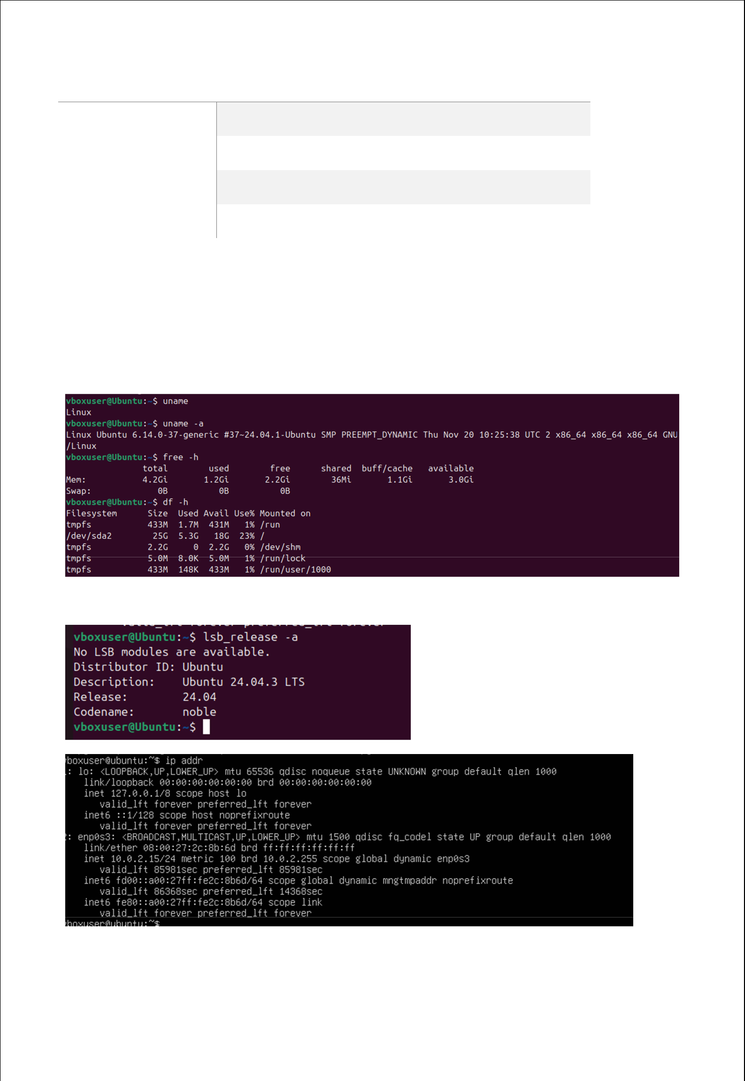
Setting | Workstation | Server
Adapter Type | Host-Only Adapter | Host-Only Adapter
Network | vboxnet0 | vboxnet0
IP Range | 192.168.56.0/24 | Same
Example IP | 192.168.56.10 | 192.168.56.20

5. System Specification Documentation:

I collected the basic information using CLI commands. The screenshots are given below;

Fabian Gill A00017906

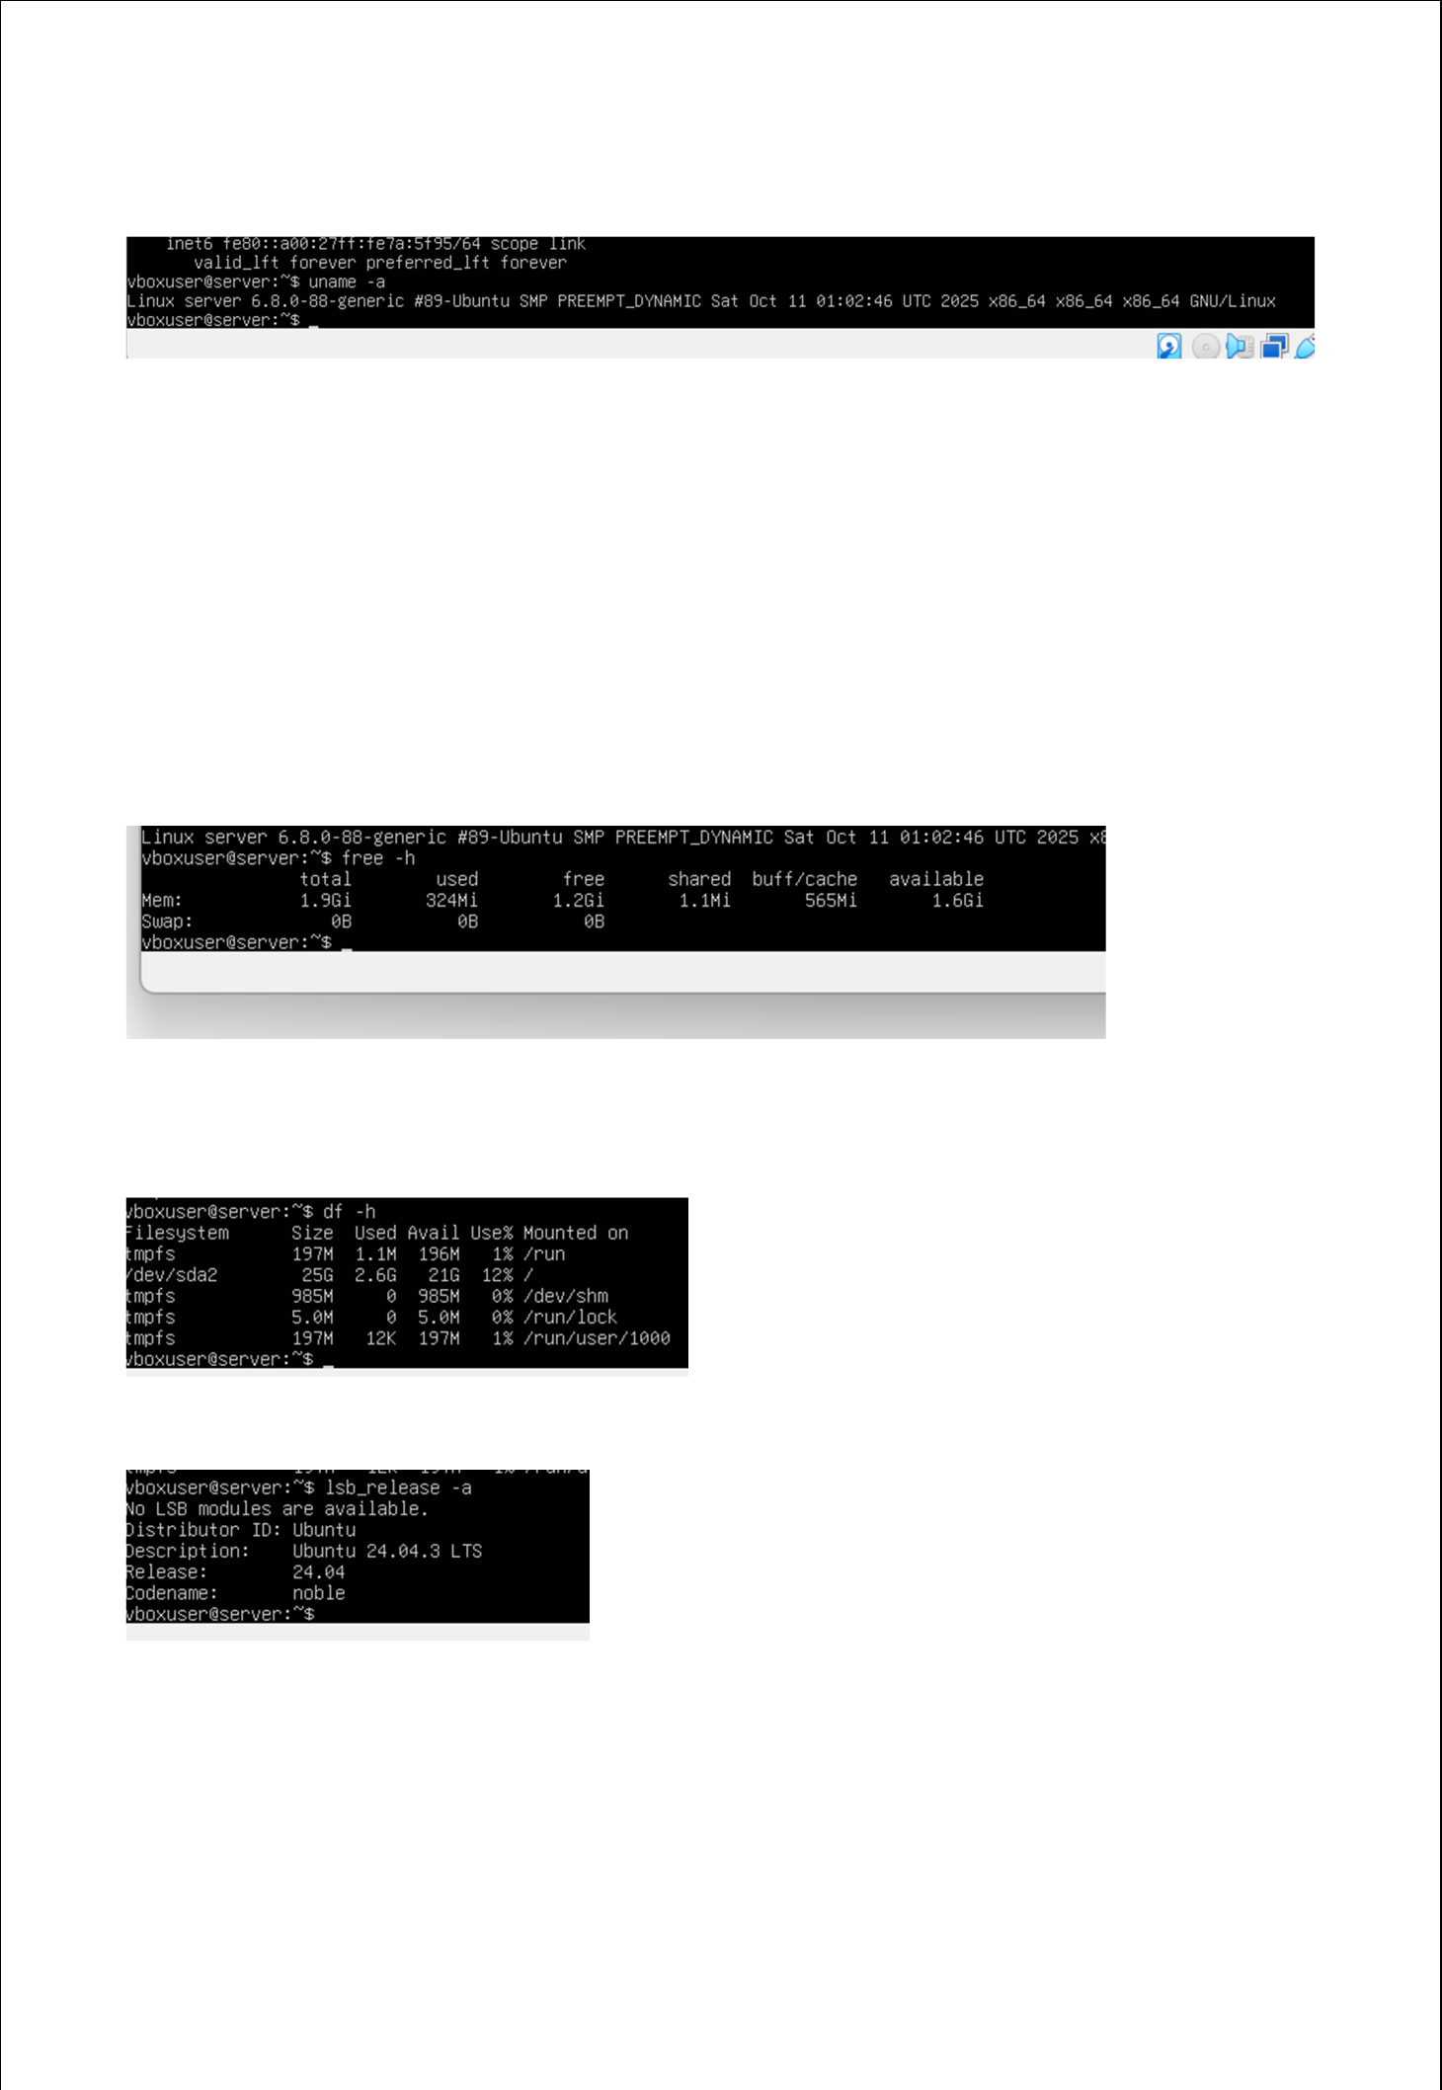

Fabian Gill | A00017906
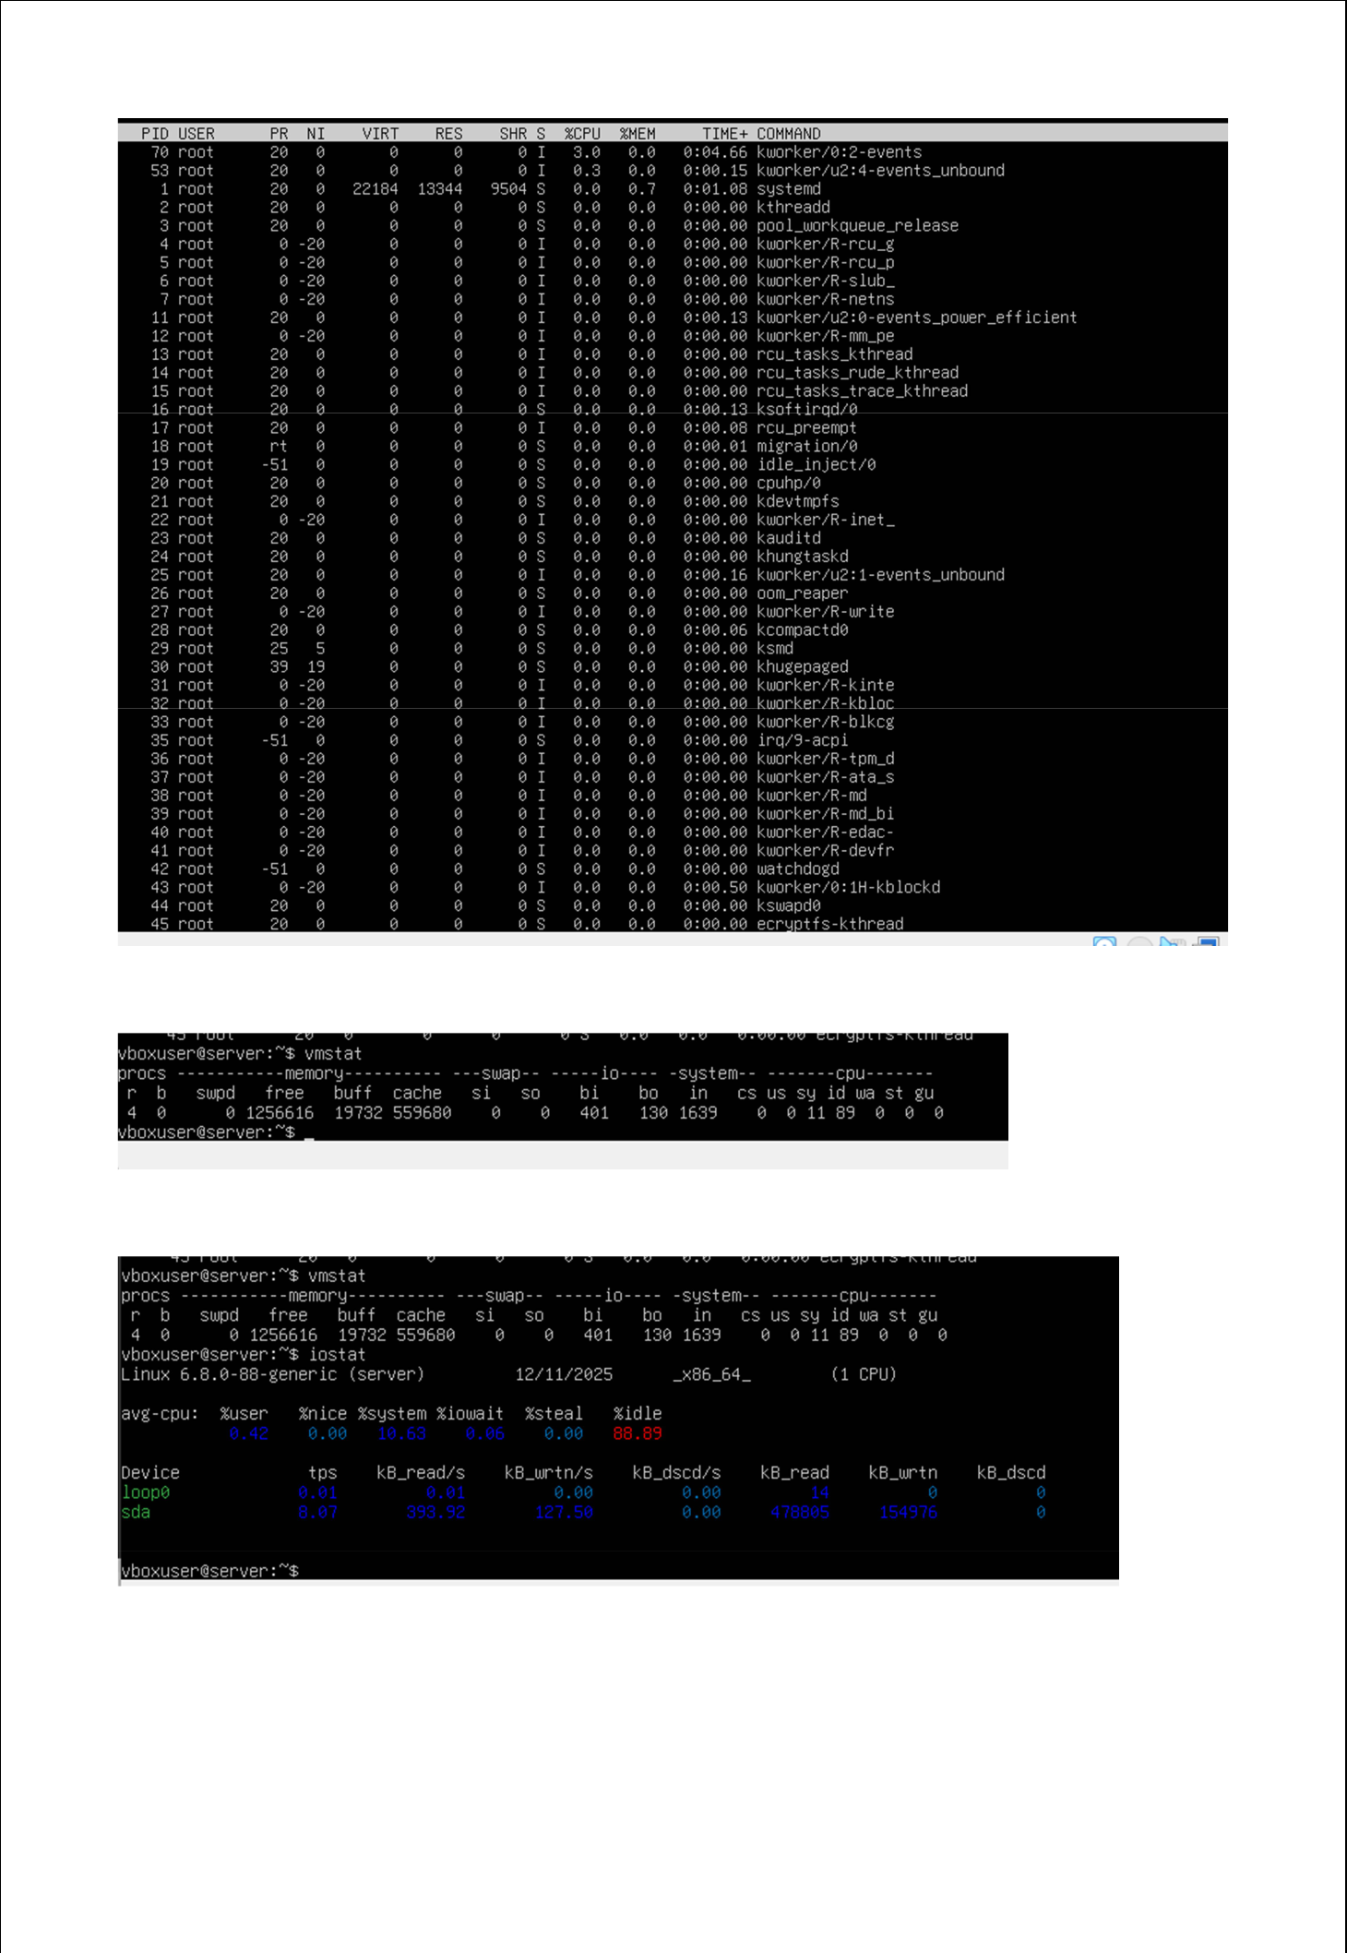

Fabian Gill | A00017906
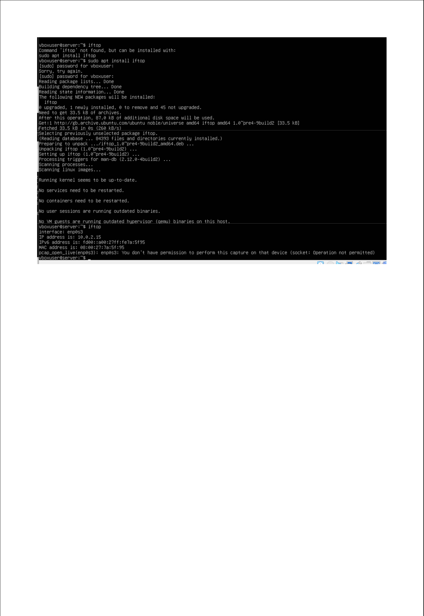

Fabian Gill | A00017906

